Part. 1: Conceptual Model

In our conceptual model, we began by grouping columns in the “olympic_medals.csv” file according to similar attributes. This was the first step to helping us classify how we could establish entities.

For example, when looking at columns “Country”, “Country Code”, “Population”, and “GDP per Capita”, we decided this like information shared characteristics that would lend itself to creating a “Country” entity. Similar groupings were made for the following:

* “Olympics” (“Games”, “Year”, “City”)
* “Athlete” (“Athlete”, “Gender”)
* “Sport” (“Sport”, “Discipline”, “Event”)
* “Medal (“Medal”)

We then looked at these groupings further in order to establish what could constitute an entity and what could be an attribute of those respective entities. We noticed that “Sport” would need to be re-thought, as this current model would not allow for an appropriate level of data integrity. In addition, when mapping out the diagram, we noticed we were going to have an “associative entity” that would be necessary due to the ternary relationship of “Athlete”, “Medal”, and “Event”.

We decided on the following finalized entities in our E-R Diagram (attributes are left off of this list and shown only on the completed E-R Diagram):

**Entities**

* Olympics
* Country
* Athlete
* Event
* Medal
* Sport
* Discipline
* Participation (Included later as an “associative” entity)

The next step was to consider how these entities could be connected through relationships. This wasn’t entirely modular – considering how the entities would be related actually helped us to finalize what our entities would be.

* Athletes are **from** countries, and countries have athletes **from** them.
* Athletes **participate** in events, and events have athletes **participate** in them.
* Medals are won by athletes **participating** at events, and events give out medals to athletes who **participate**.
* Olympics **have** events, and events **are had** at Olympics.
* Disciplines **contain** events, and events **are contained** in a specific discipline.
* Sports **contain** unique disciplines, and disciplines **belong to** a sport.

These relationship guidelines allowed us to begin to build out our E-R Diagram.

The final step was linking entities together via their relationships, and then listing appropriate attributes for each entity. This included not only attributes taken directly from the “olympic_medals.csv” itself, but also beginning to consider identifying attributes through their Primary and Foreign Keys. Pictured below is our finalized Entity Relationship Diagram.



Part 2: Logical Model

Our logical model was derived from establishing cardinality rules based on the relationships from the Entity Relationship Diagram. In addition, we specified Primary and Foreign Key relationships for each of the entity tables. We used this as an opportunity to establish data types for each attribute of each entity table in order to prepare ourselves for the Physical Design portion of the database. Finally, because “Event” involved a ternary relationship, we created an associative entity “Participation”. Pictured below is our finalized Logical Model.

Part 3: Physical Design

The final step of the process was creating the SQL DDL language to implement our design. We were able to utilize the structure of the Logical Model to code Primary and Foreign key relationships, as well as data types for the attributes in each of our tables. The documentation below shows the SQL DDL language used to implement each table into the database from Python.

**Olympics Table**

**Sport Table**

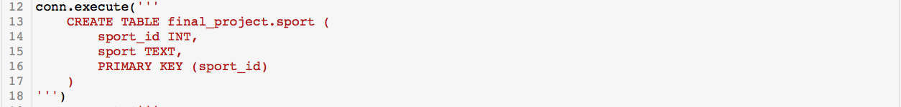

**Country Table**

**Medal Table**

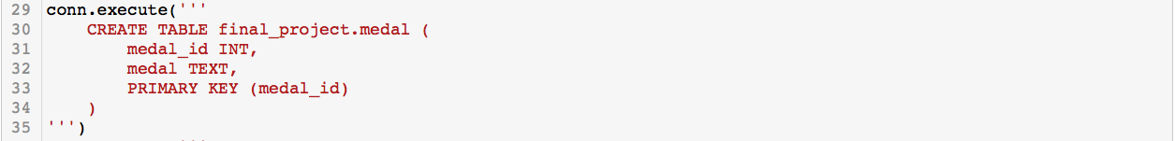

**Discipline Table**

**Event Table**

**Athlete Table**

**Participation Table**

